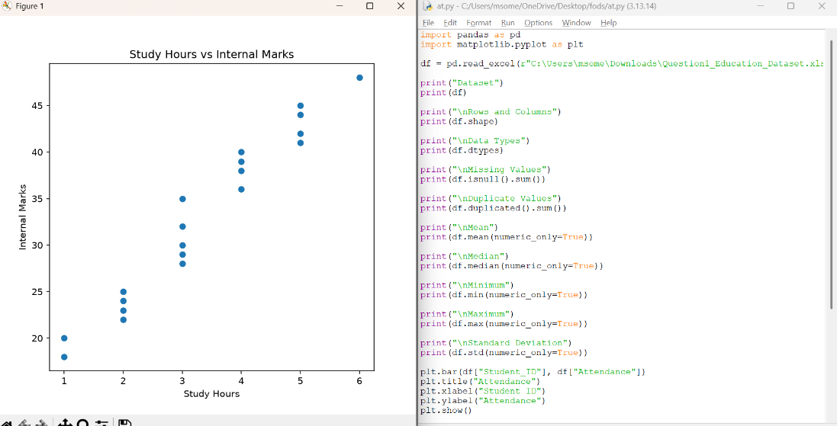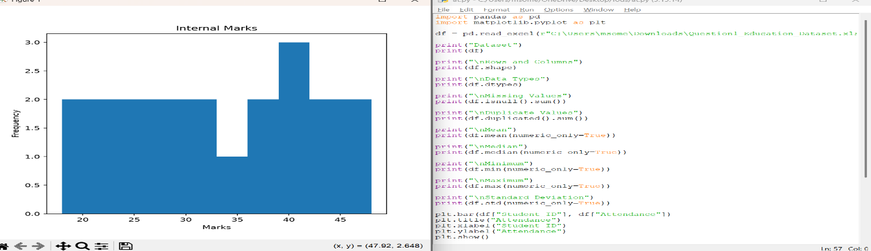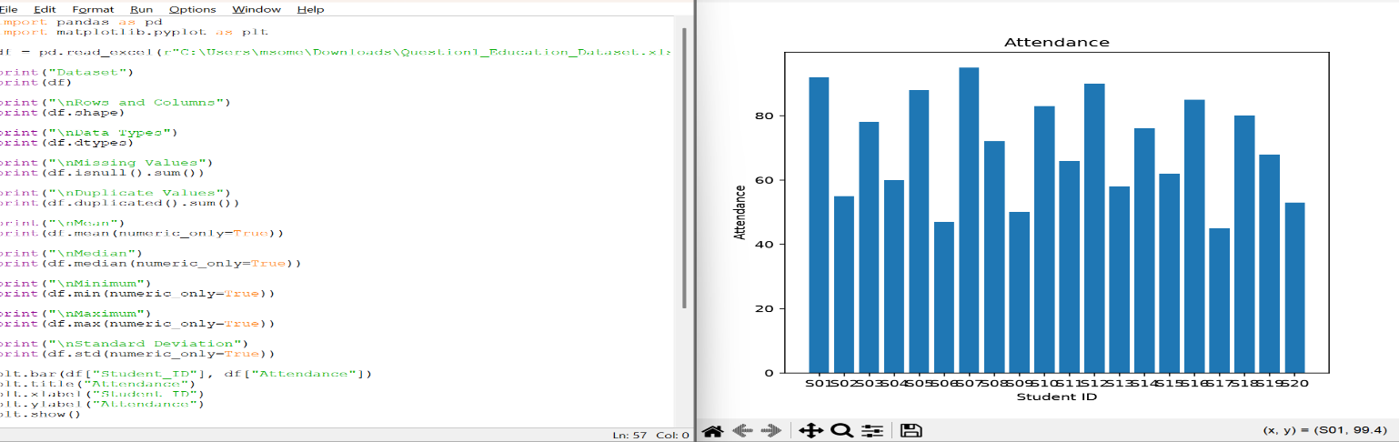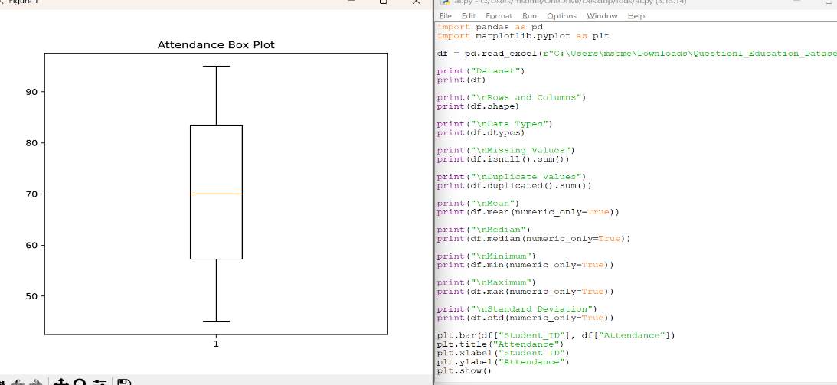
Observations
- Students with higher attendance generally scored higher internal marks.
- Students who studied more hours mostly obtained better results.
- Students with low attendance and fewer study hours were more likely to fail.
- There are no missing values and no duplicate records in the dataset.
- The scatter plot shows a positive relationship between study hours and internal marks.

Conclusion
The analysis shows that attendance and study hours have a positive impact on students' internal marks and final results. Students who attend classes regularly and study more are more likely to pass

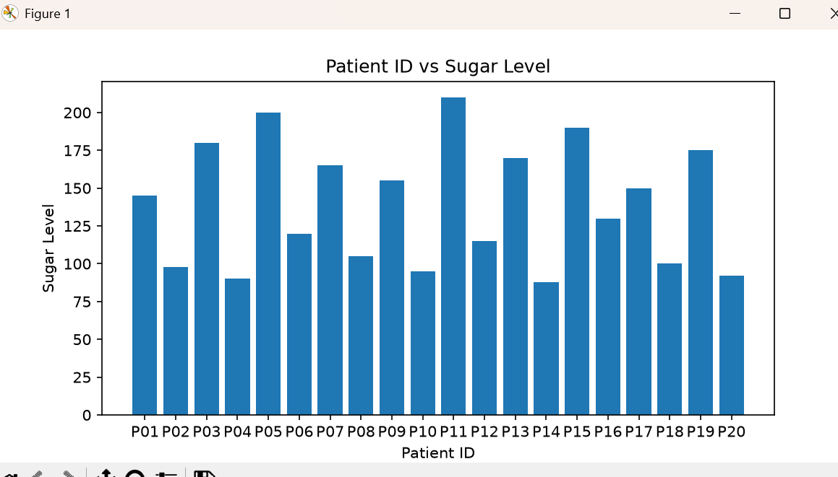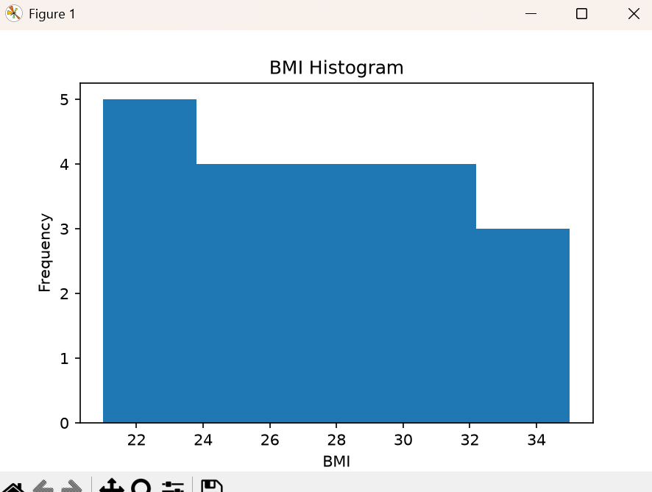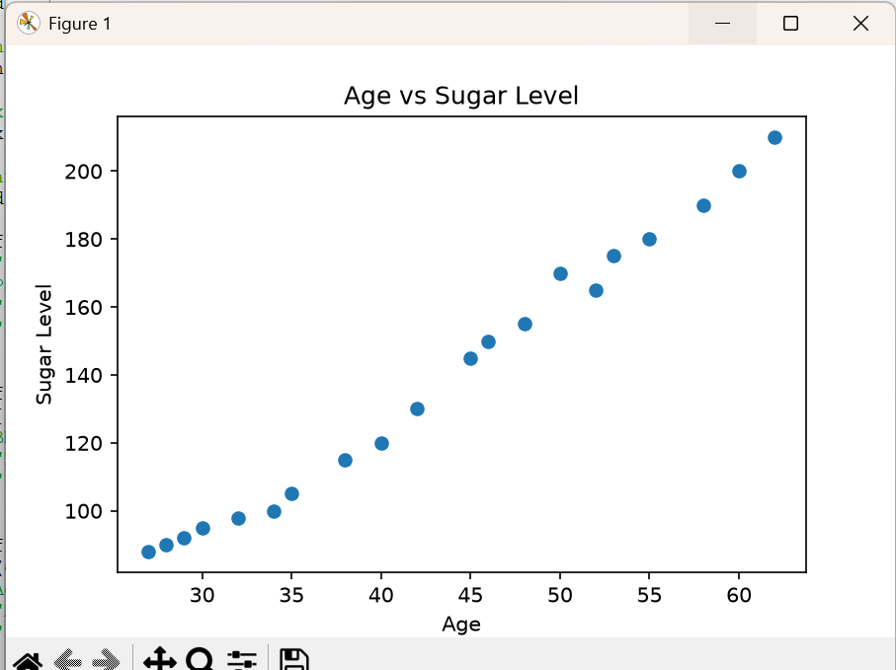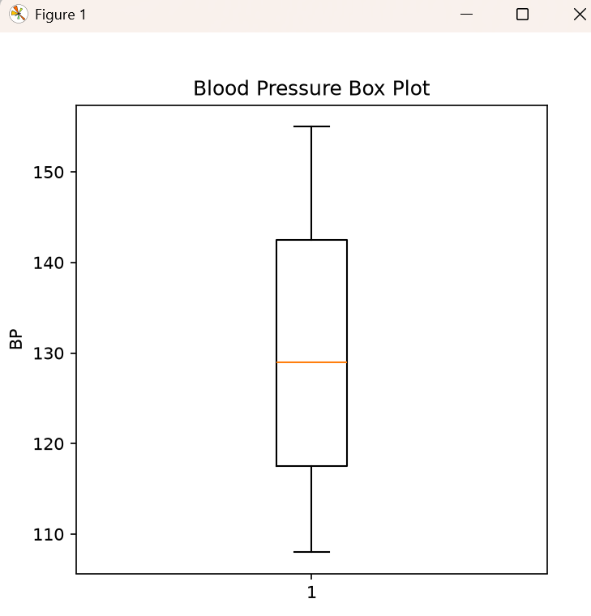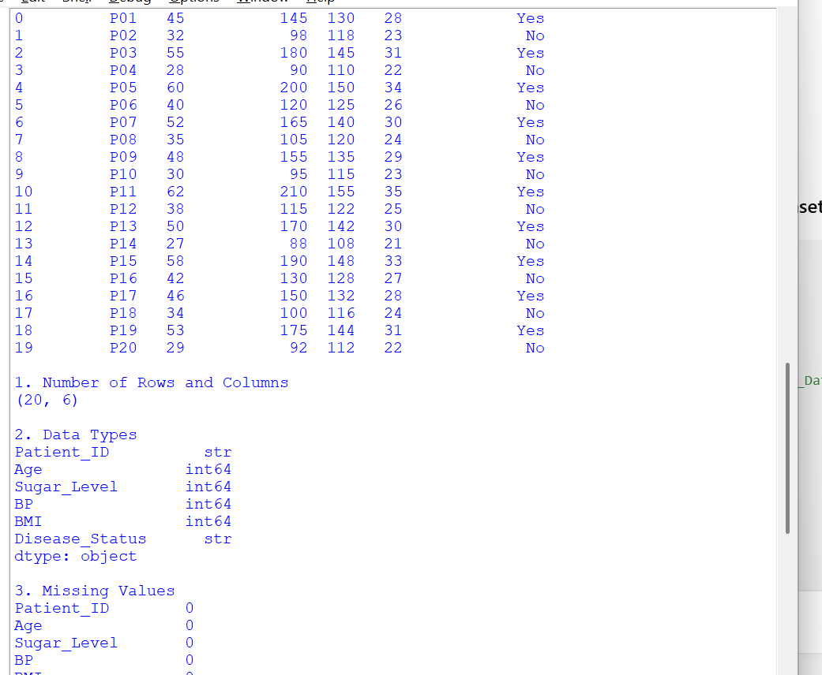
Observations
- Patients with higher sugar levels generally have higher blood pressure (BP).
- Patients with a higher BMI are more likely to have Disease Status = Yes.
- Most patients with normal sugar levels have Disease Status = No.
- There are no missing values and no duplicate records in the dataset.
- The scatter plot shows a positive relationship between age and sugar level.

Conclusion
The EDA indicates that higher sugar levels and BMI are associated with disease status. The dataset is clean and suitable for analysis, and the visualizations help identify health-related patterns.

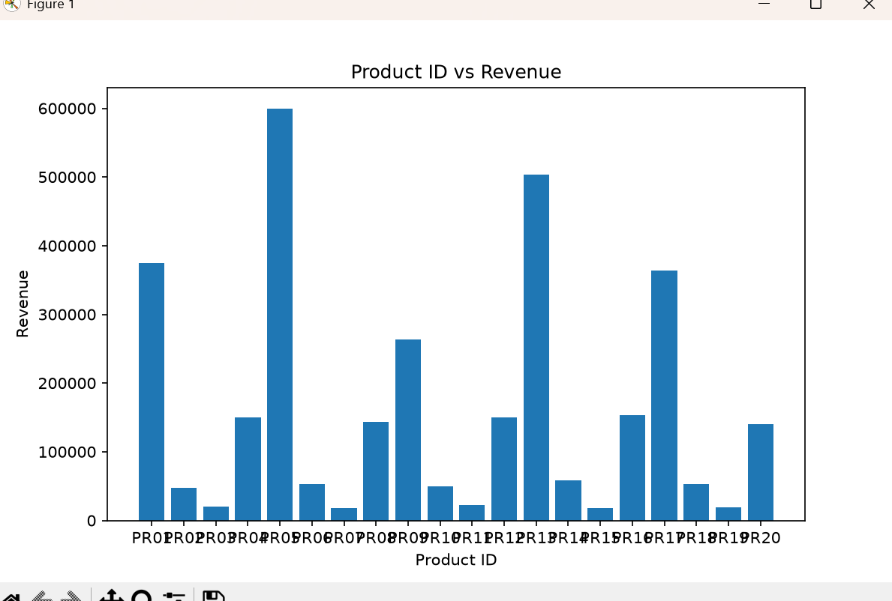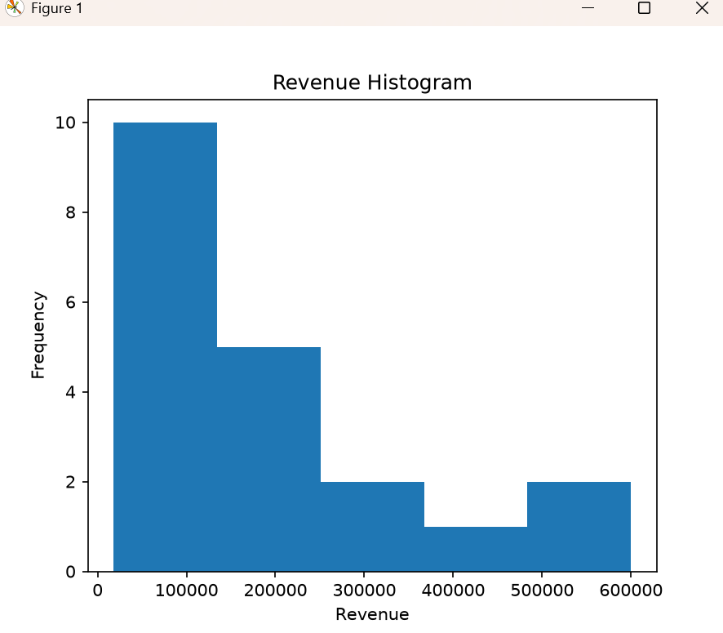
Observations
- Products with higher prices generally generate higher revenue.
- Products with higher quantities sold contribute to increased sales revenue.
- The dataset contains no missing values and no duplicate records.
- The histogram shows that most products have medium-range revenue.
- The scatter plot indicates a positive relationship between price and revenue.

Conclusion
The EDA shows that both product price and quantity sold influence total revenue. The dataset is clean, and the visualizations help identify sales trends and revenue patterns.

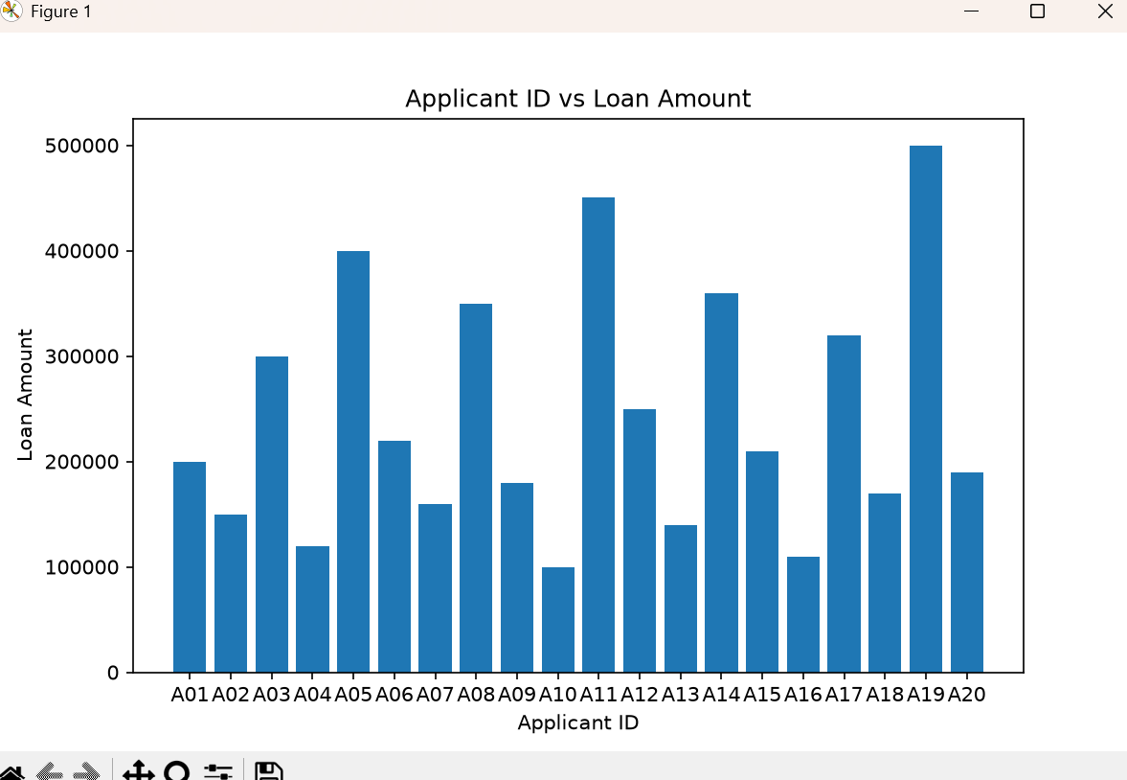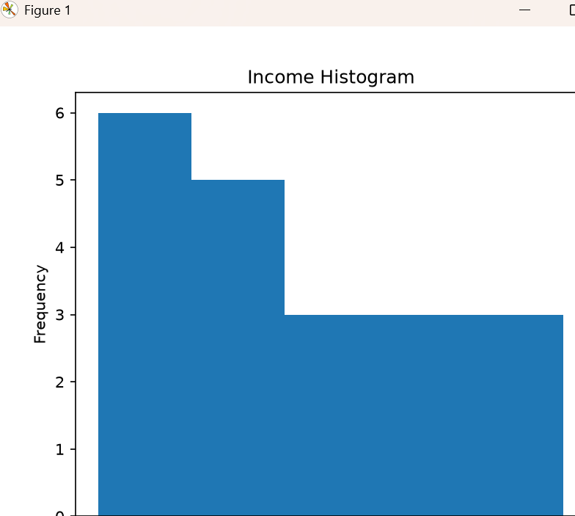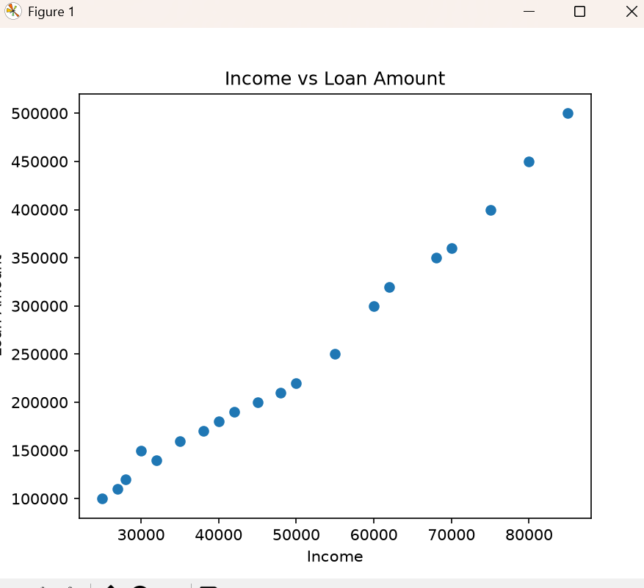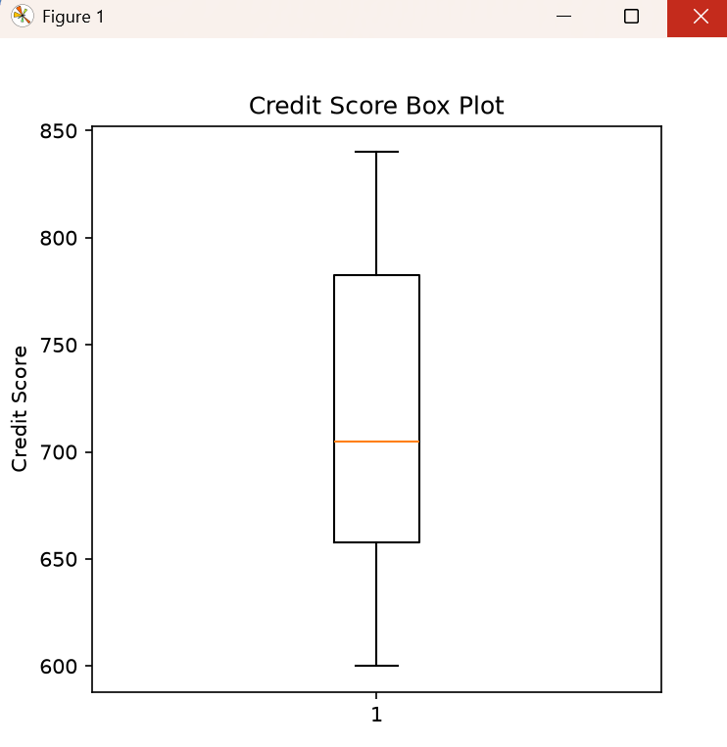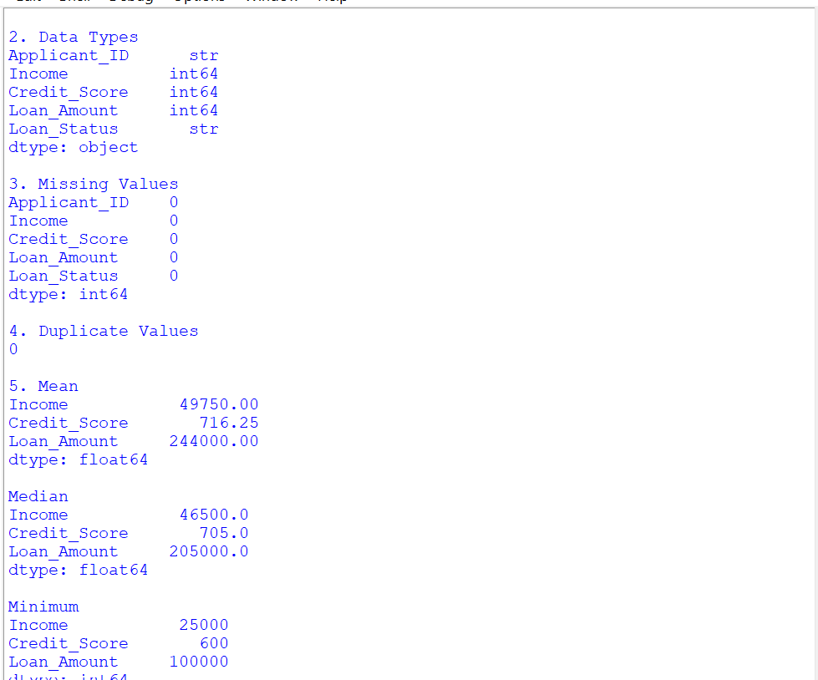
Observations
- Applicants with higher income generally receive higher loan amounts.
- Applicants with a higher credit score are more likely to have their loan approved.
- The dataset contains no missing values and no duplicate records.
- The histogram shows that most applicants have a medium income range.
- The scatter plot indicates a positive relationship between income and loan amount.
Conclusion
The EDA shows that income and credit score play an important role in loan approval and loan amount. The dataset is clean, and the graphs help identify the relationship between applicants' financial status and loan decisions.

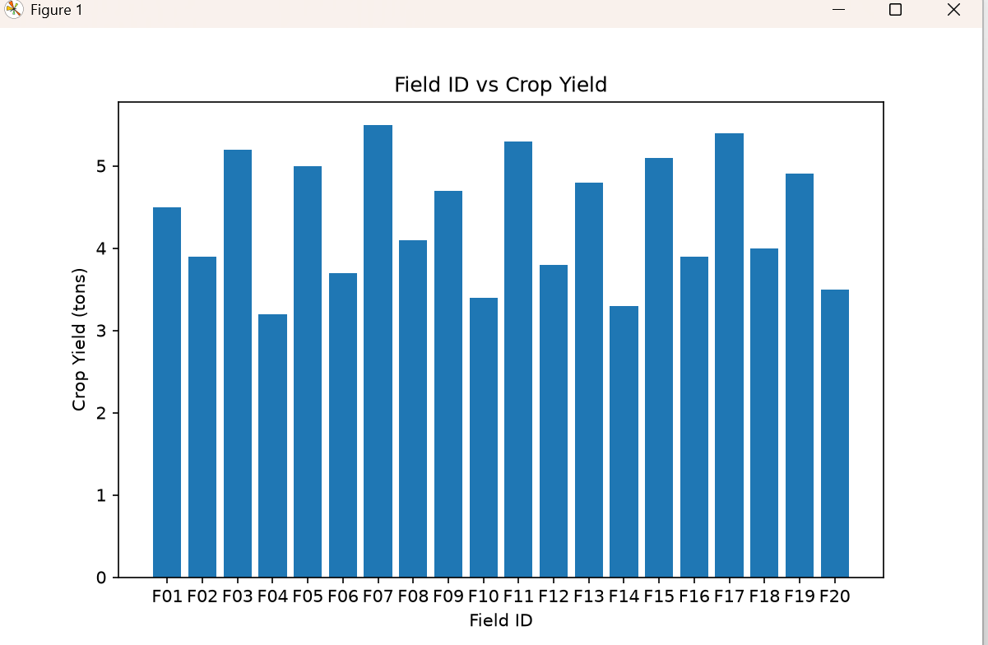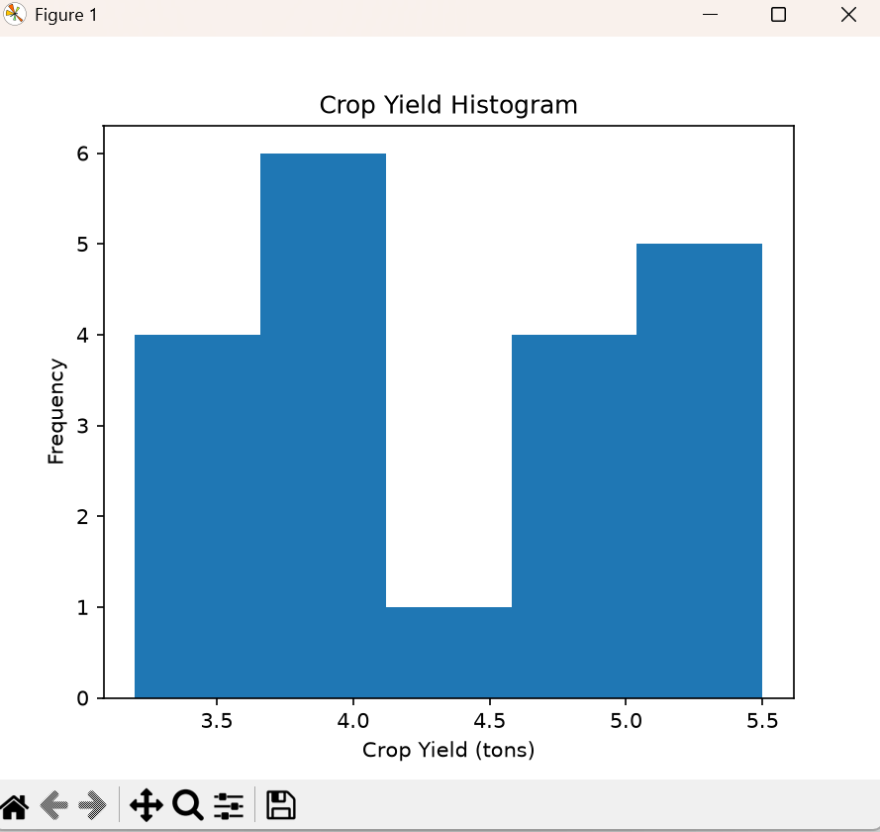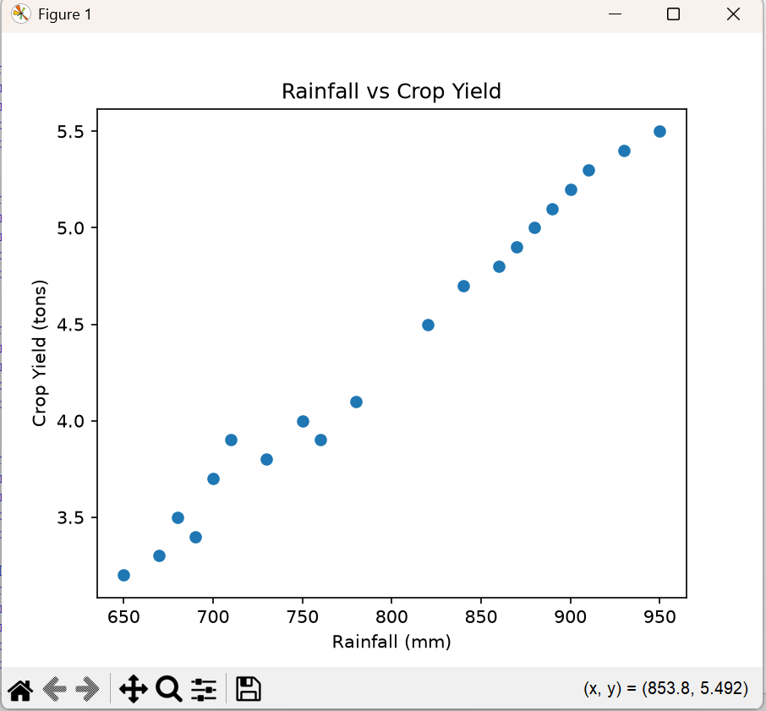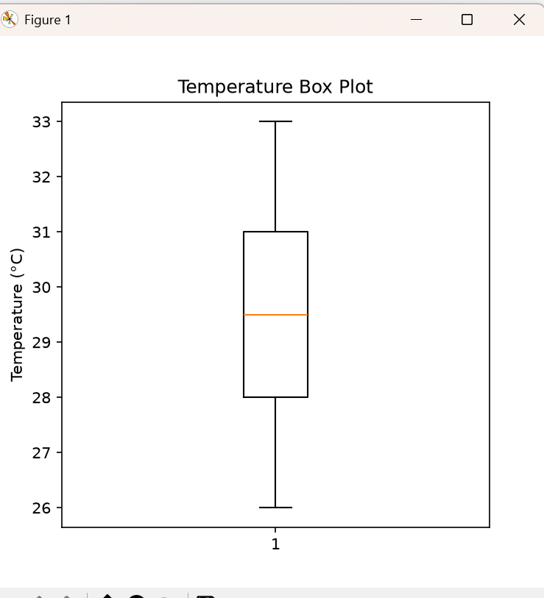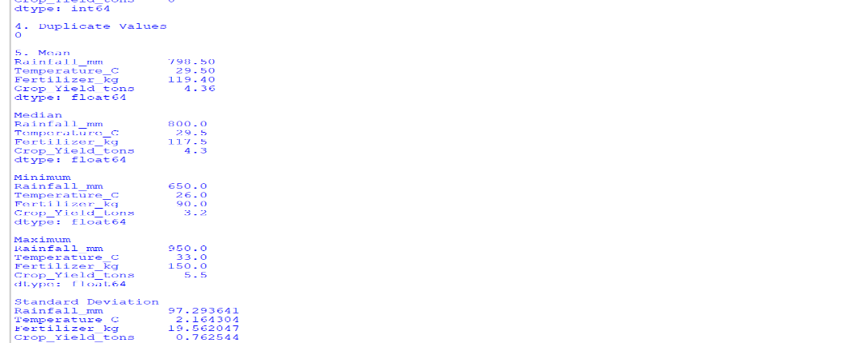
Observations
- Fields with higher rainfall generally produce higher crop yields.
- Using an adequate amount of fertilizer is associated with better crop production.
- The dataset contains no missing values and no duplicate records.
- The histogram shows that most fields have a moderate crop yield.
- The scatter plot indicates a positive relationship between rainfall and crop yield.
Conclusion
The EDA shows that rainfall and fertilizer usage have a positive effect on crop yield. The dataset is clean, and the visualizations help identify the factors influencing agricultural production.

